**Human Growth and Development**

[](http://www.google.com/url?sa=i&rct=j&q=teen+girl+clipart&source=images&cd=&cad=rja&uact=8&ved=0CAcQjRw&url=http://www.christart.com/clipart/image/bible-girl&ei=4VS5VJWmCbK0sATOhoHQBw&bvm=bv.83829542,d.cWc&psig=AFQjCNE1oKXhU_osDXyl0FNms_qN281Djg&ust=1421518323675662)

6th Grade Girls

Student/Parent Packet

Central Bucks School District

**Overview of the Female Reproductive System**

Understanding the reproductive system is as important as understanding any other organ system of the body. Encourage students to learn this system and understand the function of each part. By becoming familiar with the female anatomy, girls can better grasp what happens during the menstrual cycle. Require that they learn the correct terminology as well. Review pronunciation. Help students understand the approximate location, size and shape of each organ.

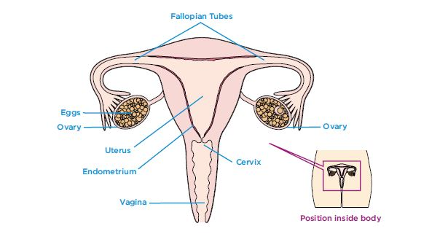

**Cervix** – The base of the uterus with a small opening between the uterus and vagina.

**Egg** – Also called an ovum; the female reproductive cell.

**Endometrium** – Spongy, blood-filled tissue that lines the uterus and nourishes a developing embryo. Discharged during menstruation.

**Fallopian tubes** – Two tubes connecting the ovaries to the uterus through which the egg travels.

**Ovaries** – Two glands, one on either side of the uterus, that contain a woman’s egg cells and produce estrogen, progesterone and other hormones.

**Ovulation** – Moment at which an egg is released from an ovary.

**Urethra** – Tube that carries urine from the bladder out of the body.

**Uterus** – Also called the womb, a muscular organ, lined with soft, nourishing tissue that carries the fetus until birth.

**Vagina** – The flexible passageway leading from the cervix to the outside of the body. Menstrual fluid flows through the vagina.

Educators and students can find more terms and definitions at

**Physical changes at puberty for girls**

The female stages of development are typically described by the five Tanner stages of breast development and pubic hair growth, along with other signs of female maturation: the growth spurt, the onset of vaginal discharge, and the start of menstruation. The drawing below describes these five stages with average age ranges.

It is important to emphasize that each girl's progression through the stages will be slightly different according to her own body's timetable.

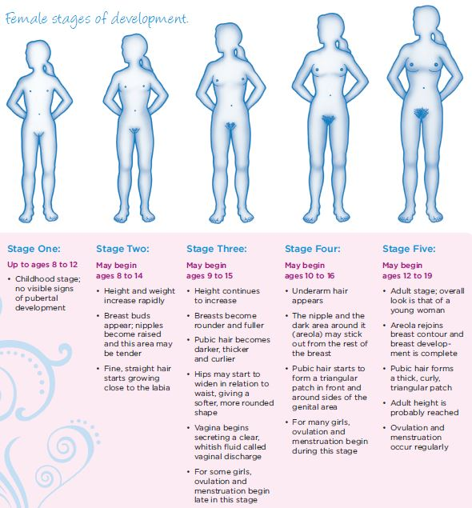

**Overview of the Male Reproductive System**

Understanding the reproductive system is as important as understanding any other organ system of the body. Encourage students to learn this system and understand they function of each part. By becoming familiar with the male anatomy, boys can better comprehend the changes in their bodies as they grow. Require that they learn the correct terminology as well. Review pronunciation.

Begin by explaining that the main purpose of the male reproductive system is to produce sperm-the male reproductive cells. During puberty, testosterone enables the testicles to start producing mature sperm for the first time. (When a sperm cell reaches an egg of a woman and fertilization takes place, the woman becomes pregnant with a baby.) Sperm is combined with other fluid in the vas deferens to make the seminal fluid, which is called semen.

To explain how semen leaves the body (through ejaculation), you may want to trace the path of the sperm from the testicles, through the vas deferens (sperm duct), seminal vesicles, prostate gland, and the urethra. Define erection and ejaculation. Be sure to explain that urine also leaves the body through the urethra, but never at the same time as semen.

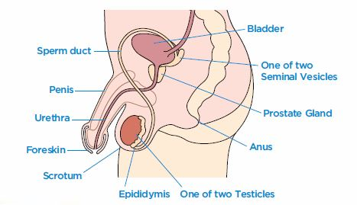

**Epididymis**: Tube at the back of each testicle that carries sperm to the vas deferens (sperm duct)

**Foreskin**: This fold of skin covers the end of the penis. Not all boys have a foreskin because some cultures, it is removed (an operation called circumcision) when a baby boy is only a few days or weeks old. Uncircumcised boys and men pull the foreskin back and wash under it as part of daily hygiene.

**Penis**: Male sex organ; also used to urinate.

**Prostate Gland**: Gland next to the bottom of the bladder; it forms a fluid that combines with sperm and a fluid from the seminal vesicles to make sperm.

**Scrotum**: Sac of skin that holds the testicles, just underneath the penis.

**Semen**: Male reproductive cells.

**Seminal vesicles**: Two glands on either side of the bladder that secrete seminal fluid.

**Sperm**: Male reproductive cells.

**Testicles**: Also called the testes; two oval-shaped organs that are contained in the scrotum. They produce the male hormone testosterone and sperm.

**Urethra**: Tue that carries urine and semen out of the body, but not at the same time.

**Vas Deferens**: Tubes in which sperm is combined with other fluids from the prostate gland and seminal vesicles to make sperm.

**Physical Changes at Puberty for Boys**

The male stages of development are typically described by the five Tanner stages of genital and pubic hair growth, along with other signs of male maturation: the deepening of the voice, the growth spurt, muscle development, and the growth of facial and body hair. It is important to emphasize that each boy’s progression through the stages will be slightly different according to his own body’s timetable, and boys usually move through the stages of puberty one or two years later than girls.

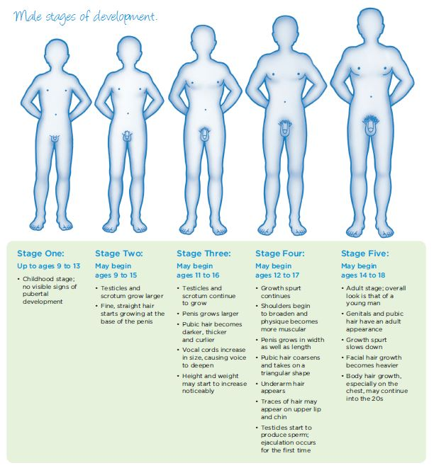

**Unit III**

**Vocabulary Quiz**

Match the words at the top with their description below.

1. Fertilization F. Fetus
2. Umbilical Cord G. Placenta
3. Embryo H. Amniotic Fluid
4. Contractions I. Gestation
5. Birth Canal J. Labor
6. ____ The period between conception and birth of a baby - around nine months.
7. ____ The moment when a sperm joins an egg, and an embryo is formed.
8. ____ The growing fertilized egg from conception until the end of the second month of pregnancy.
9. ____ This clear liquid surrounds a baby during pregnancy.
10. ____ The ropelike cord connecting the growing baby to the placenta.
11. ____ The growing unborn baby from the second month after conception until birth.
12. ____ The process of childbirth.
13. ____ The action of the muscles of the uterus that help to push the baby during childbirth.
14. ____ The passage through which a baby is born.
15. ____ A structure from which the developing baby receives its nourishment. It

is connected to the umbilical cord.